K-3 Arts Education: Week of May 4 - 8, 2020
Tokonoma project

The tokonoma is a special room in a Japanese style of house. It is special because of the respect that is given it. The room is special because of a special tea ceremony that is held in it, usually with special guests. In that room, a special flower or plant arrangement can be found. These plants are chosen carefully according to the season. So at this time of year, there would usually be found some kind of blossom.

Ideas on what yours could look like:
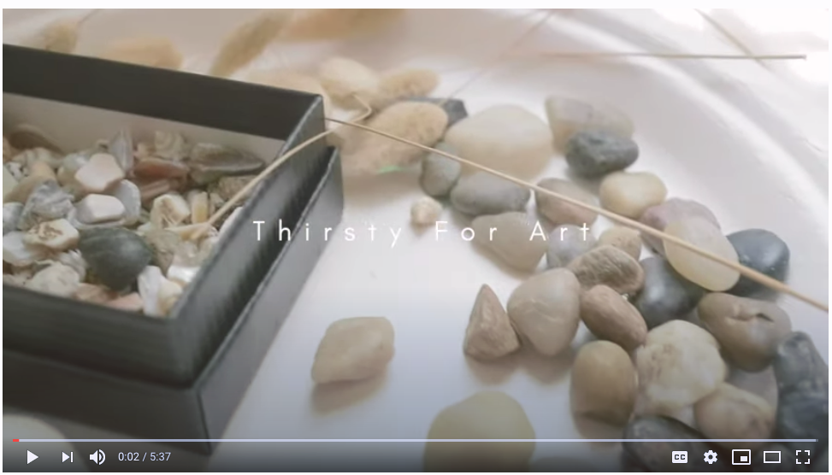

Video 1

https://www.youtube.com/watch?v=SB05jNRFmI0 This Youtube video with ideas is called “Nature Art Therapy.” Stop the video at 3:55 … the rest is reflective writing. We won’t do that!
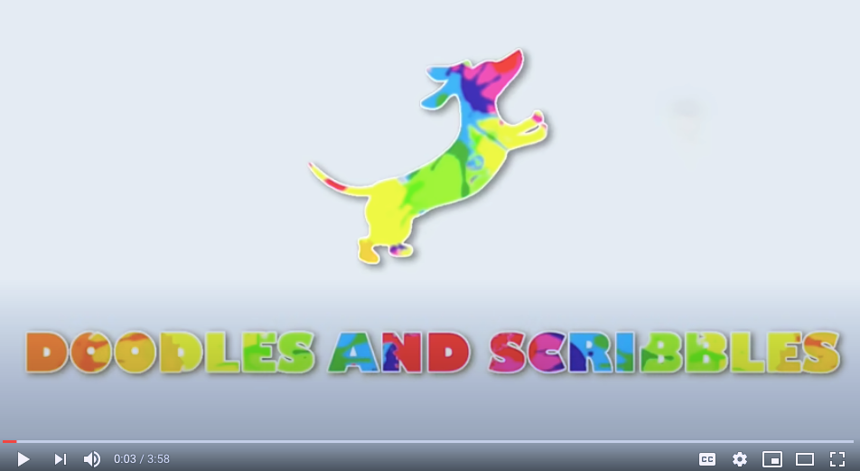

Video 2

https://www.youtube.com/watch?v=FN7w39QKxjk This Youtube is called “Found Object Art: Nature Art.” This video highlights an artist who works with the idea called Assemblage Art. This video shows what to do if you have no box. You can lay out the materials on a flat piece of carpet even! No worries … just photo what you have made and send it to me. And … be sure and clean up the mess for mom!

What to Do:
We are going to make tokonomas as our art project this week! To do that, you will need to go on a nature hunt to find special or amazing things outside in nature around your house. After you find those items, take special care to organize and arrange them in a little box. It is not intended that you use glue to hold them down. You just arrange … and enjoy!

Step 1:
Put on your outside clothes and go look for these items! Have fun.

- a blossom | 2.  a stick with one branch coming off it | 3.  something prickly | 4.  something soft
5.  something smooth | 6.  something bumpy | 7.  something colourful | 8.  something green
9.  something round | 10. something with spots | 11.  something with 3 or more parts all attached | 12. something unique and special that you found!

Step 2:
Put all your found items on a table or a piece of concrete or other flat surface and take one picture of all the things that you found.

Step 3:
Find a box that you can use to arrange your items. A cereal box with one of the sides cut off would work just fine. I used a box that I got from the Old Farm Market with my groceries. Or lay them out like the 2nd video showed.

Step 4:
Organize all your found objects to make a special arrangement in your box. They do not need to go in order. Take your time to arrange until you are really happy. Make a little sign to go with it:

My Tokonoma by (Your name)

Step 5:
Send me your 2 photos to:
tlassche@sd79.bc.ca or lassche@shaw.ca

Have fun! Mr. Lassche

